BANK CUSTOMER
CHURN ANALYSIS
REPORT

Predictive Analytics & Customer Retention Intelligence

10,000  Total Customers | 20.37%  Overall Churn Rate | 0.861  Best Model AUC | $78.67M  Revenue at Risk

Prepared by: Rinsha Varangot
Tools: Python 3.12 | Pandas | NumPy | Seaborn | Matplotlib | scikit-learn | Microsoft Power BI
1. Executive Summary

This report delivers a comprehensive end-to-end churn analysis for a retail bank, covering 10,000 customers across France, Germany, and Spain. Using Python-based machine learning and interactive Power BI dashboards, the study identifies the root causes of customer attrition and provides actionable, data-driven recommendations to reduce churn below the 15% industry benchmark.

1.1 Business Context
Customer churn is one of the most costly challenges in retail banking. At the current churn rate of 20.37%, the bank is losing over one-fifth of its customer base annually. With $78.67M in balances held by high-risk customers, proactive intervention is both urgent and financially justified.

1.2 Key Metrics at a Glance

10,000  Total Customers | 2,037  Churned | 7,963  Retained | 20.37%  Churn Rate

1,127  High Risk Customers | $78.67M  Revenue at Risk | 89.12%  Model Accuracy | 86.53%  Precision

0.861  Model AUC | 55.18%  Recall (Capture) | 1,124  Identified Churners | 913  Missed Churners

1.3 Top 7 Findings
- Churn rate of 20.37% exceeds the 15% industry benchmark by 5.37 percentage points.
- Germany churns at 32.44% — more than double France (16.15%) and Spain (16.67%).
- The 46-60 age group has a 51.12% churn rate — over half of this segment leaves.
- Germany + 46-60 combined reaches 67.33% churn — the single highest risk cell.
- Customers with 3-4 products churn at 82.71%-100% — product overselling is a critical problem.
- Inactive members churn at 26.85% vs 14.27% for active members — nearly double.
- Female customers churn at 25.07% vs 16.46% for males — a significant 8.6-point gap.

Bottom Line: Retaining even 30% of the 1,127 high-risk customers would preserve over $23M in customer balances. The Gradient Boosting model provides the bank with the predictive capability to identify these customers before they leave.
2. Dataset Overview & Data Cleaning

2.1 Raw Data Profile
The dataset contains 10,000 customer records. After removing non-analytical identifiers (CustomerId, Surname), 11 features were available for analysis. No missing values or duplicate records were found, making this a high-quality dataset requiring minimal preprocessing.

Feature | Data Type | Range / Values | Role
CreditScore | Integer | 300 – 850 (clipped) | Predictor
Geography | Categorical | France, Germany, Spain | Predictor
Gender | Categorical | Male, Female | Predictor
Age | Integer | 18 – 100 (clipped) | Predictor
Tenure | Integer | 0 – 10 years | Predictor
Balance | Float | $0 – $250,898 | Predictor
NumOfProducts | Integer | 1 – 4 products | Predictor
HasCrCard | Binary | 0 = No, 1 = Yes (70.5% yes) | Predictor
IsActiveMember | Binary | 0 = Inactive, 1 = Active (51.5%) | Predictor
EstimatedSalary | Float | ~$12 – $200K | Predictor
Exited | Binary | 0 = Retained, 1 = Churned | Target (20.37%)

2.2 Cleaning Steps Applied
- Dropped CustomerId and Surname — non-analytical, no predictive value.
- Removed duplicate rows — 0 duplicates found, all 10,000 records retained.
- Clipped CreditScore to valid range 300-850 — removed domain-illegal outliers.
- Clipped Age to valid range 18-100 — removed unrealistic age values.
- Validated all binary columns (HasCrCard, IsActiveMember, Exited) — all clean.

Data Quality: Zero missing values. Zero duplicates. Only 2 cleaning operations required (outlier clamping). This dataset is production-ready with minimal preprocessing overhead.
3. Feature Engineering

Six new features were engineered from the original columns to capture latent behavioural patterns and improve model performance.

Feature | Formula | Type | Business Rationale
BalanceToSalary | Balance ÷ (Salary + 1) | Ratio | Measures financial leverage relative to income
ProductsPerYear | NumOfProducts ÷ (Tenure + 1) | Ratio | Product adoption velocity over customer lifetime
AgeGroup | Bins: 18-30, 31-45, 46-60, 60+ | Ordinal | Demographic segmentation for targeted analysis
CreditScoreBand | Poor/Fair/Good/VeryGood/Exceptional | Ordinal | Credit health category for risk stratification
IsZeroBalance | 1 if Balance = 0, else 0 | Binary | Identifies disengaged, dormant accounts
EngagementScore | IsActive + HasCard + NumProducts | Integer (0-6) | Composite customer engagement index

3.1 Engineering Impact on Churn
Feature | Value | Churn Rate | Insight
EngagementScore | 6 (Maximum) | 0.00% | Fully engaged customers never churn
EngagementScore | 5 | 11.85% | High engagement = strong retention
EngagementScore | 2 | 28.29% | Low engagement = elevated risk
EngagementScore | 1 | 34.54% | Very low engagement = high risk
IsZeroBalance | 1 (Zero) | ~19% | Dormant accounts at moderate risk
AgeGroup | 46-60 | 51.12% | Highest churn across all age segments
CreditScoreBand | Poor | 22.02% | Highest churn across credit bands

Engineering Win: EngagementScore proved to be the 3rd most important feature in Random Forest. It captures a dimension no single original feature could — the combined effect of activity, card ownership, and product depth on retention.
4. Exploratory Data Analysis (EDA)

4.1 EDA Overview Dashboard
The following dashboard summarises all key churn patterns across geography, demographics, products, and engagement in a single view.

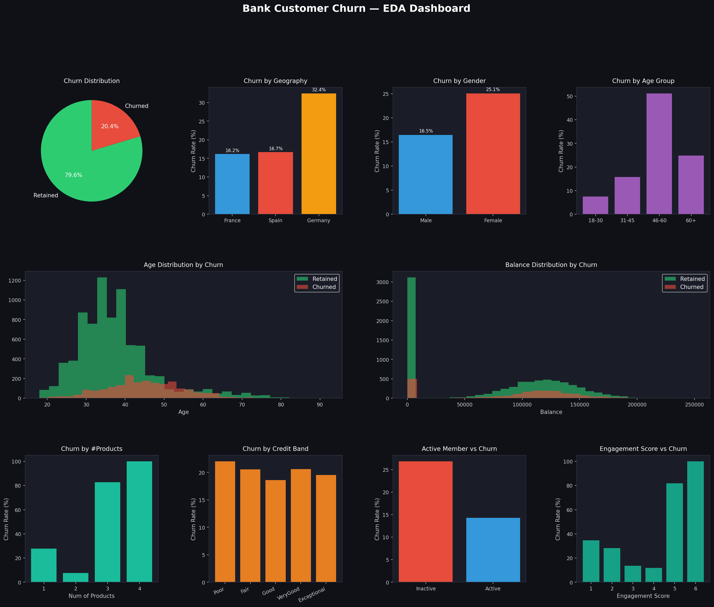
Figure 1: Bank Customer Churn — Full EDA Dashboard (9-panel overview)

4.2 Correlation Matrix
The correlation matrix reveals relationships between all numerical features and the target variable (Exited).

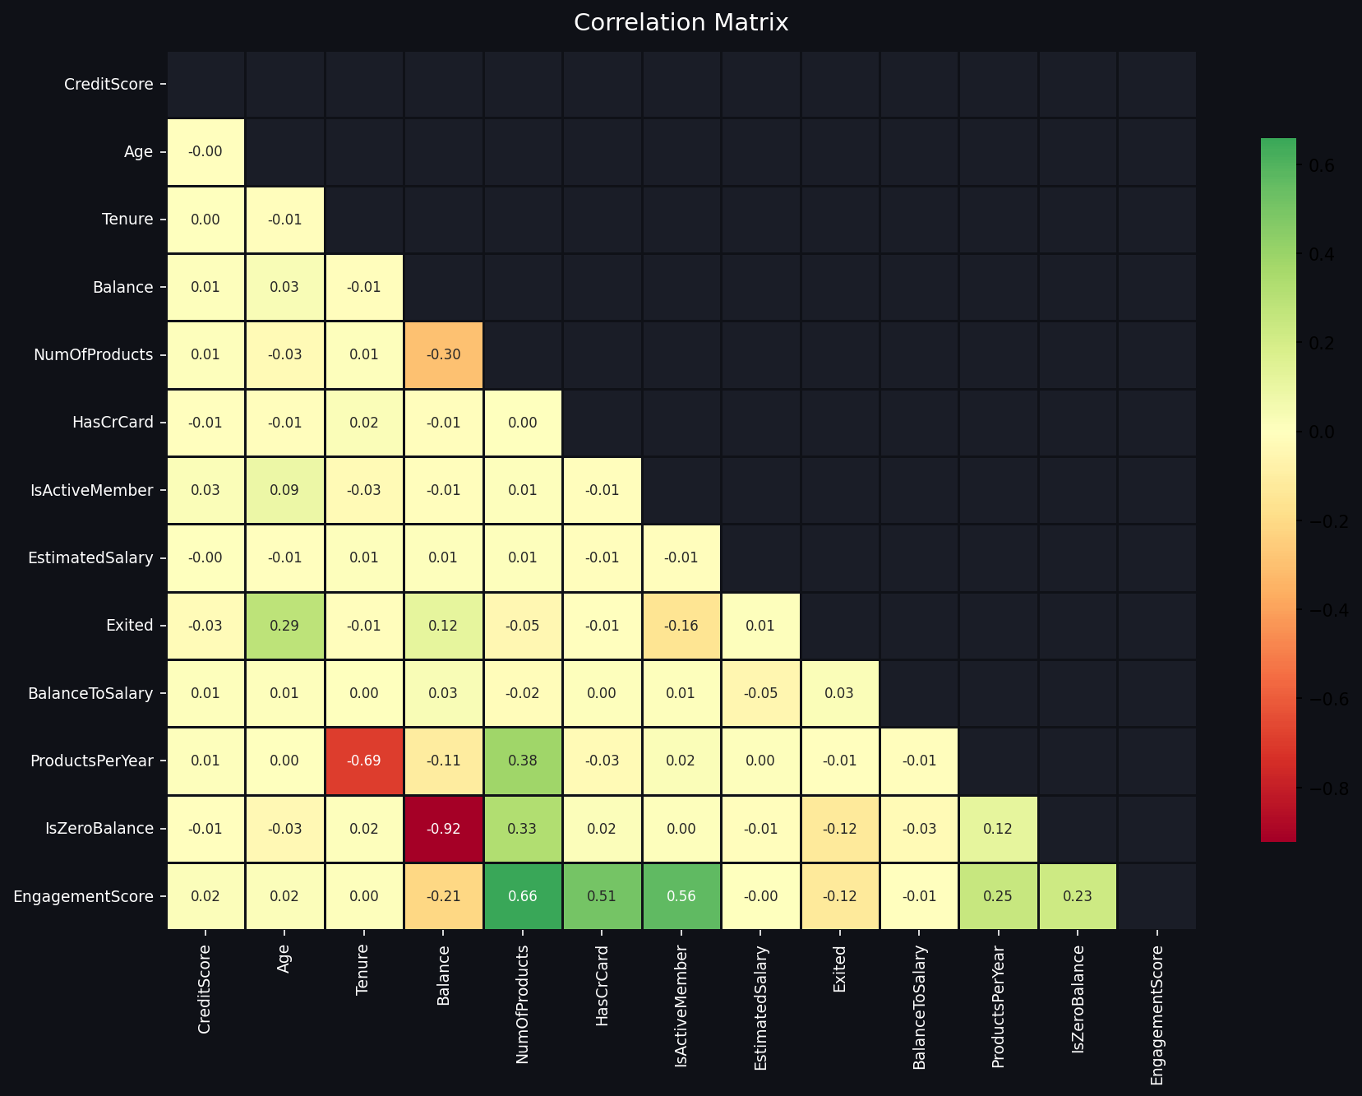
Figure 2: Correlation Matrix — key correlations with Exited: Age (+0.29), IsActiveMember (-0.16), Balance (+0.12)

Key Correlations with Churn (Exited):
Feature | Correlation | Direction | Interpretation
Age | +0.29 | Positive | Older customers significantly more likely to churn
IsActiveMember | -0.16 | Negative | Active members are strongly less likely to churn
Balance | +0.12 | Positive | Higher balances slightly associated with churn
NumOfProducts | -0.05 | Negative | More products weakly associated with retention
CreditScore | -0.03 | Negligible | Credit score has minimal direct churn correlation
EstimatedSalary | +0.01 | Negligible | Salary has almost no direct impact on churn

Note: Low correlations do not mean features are unimportant — they may have non-linear relationships with churn which tree-based models (Random Forest, Gradient Boosting) capture effectively through feature interactions.

4.3 Geography & Gender Analysis

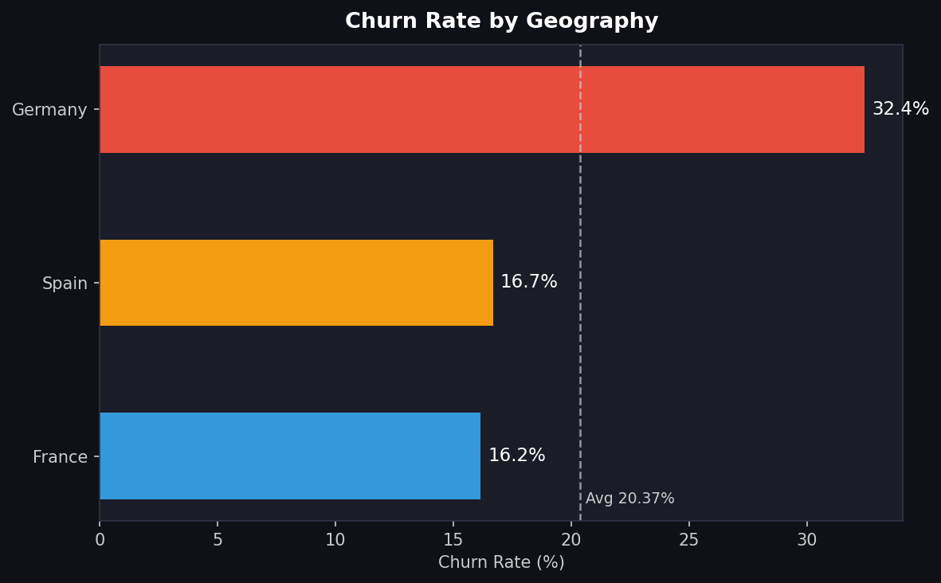 | 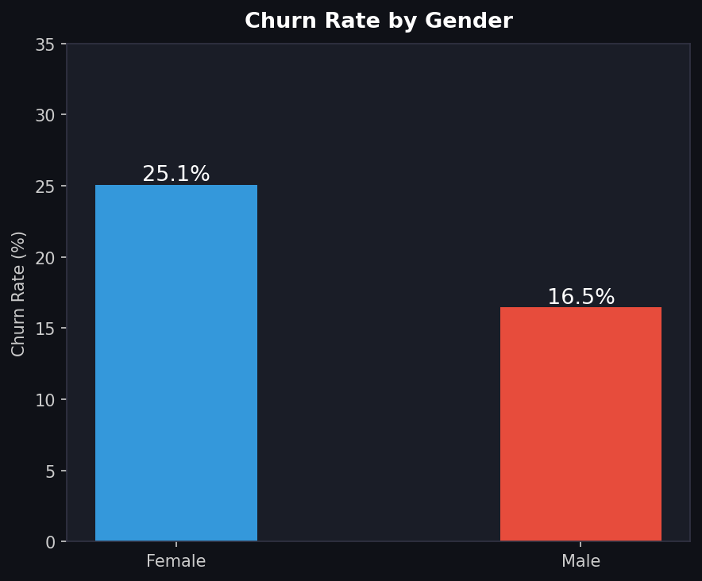
Figure 3: Churn by Geography (left) — Germany at 32.44%; Churn by Gender (right) — Female at 25.07%

Geography | Customers | Churned | Churn Rate | vs Overall
France | 5,014 | 810 | 16.15% | -4.22% below avg
Spain | 2,477 | 413 | 16.67% | -3.70% below avg
Germany | 2,509 | 814 | 32.44% | +12.07% above avg ⚠
Total | 10,000 | 2,037 | 20.37% | Benchmark

Germany Alert: Germany represents only 25% of the customer base but generates 40% of all churn. This geographic imbalance is the single most important finding for targeted retention investment.

4.4 Age Group & Products Analysis
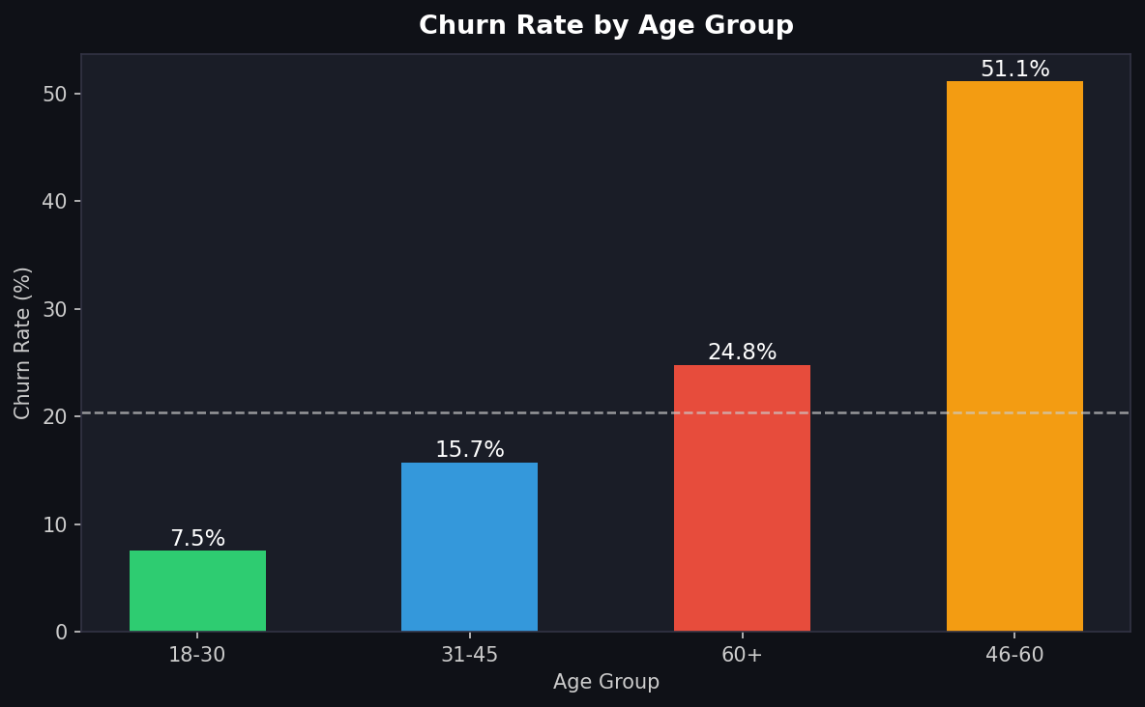 | 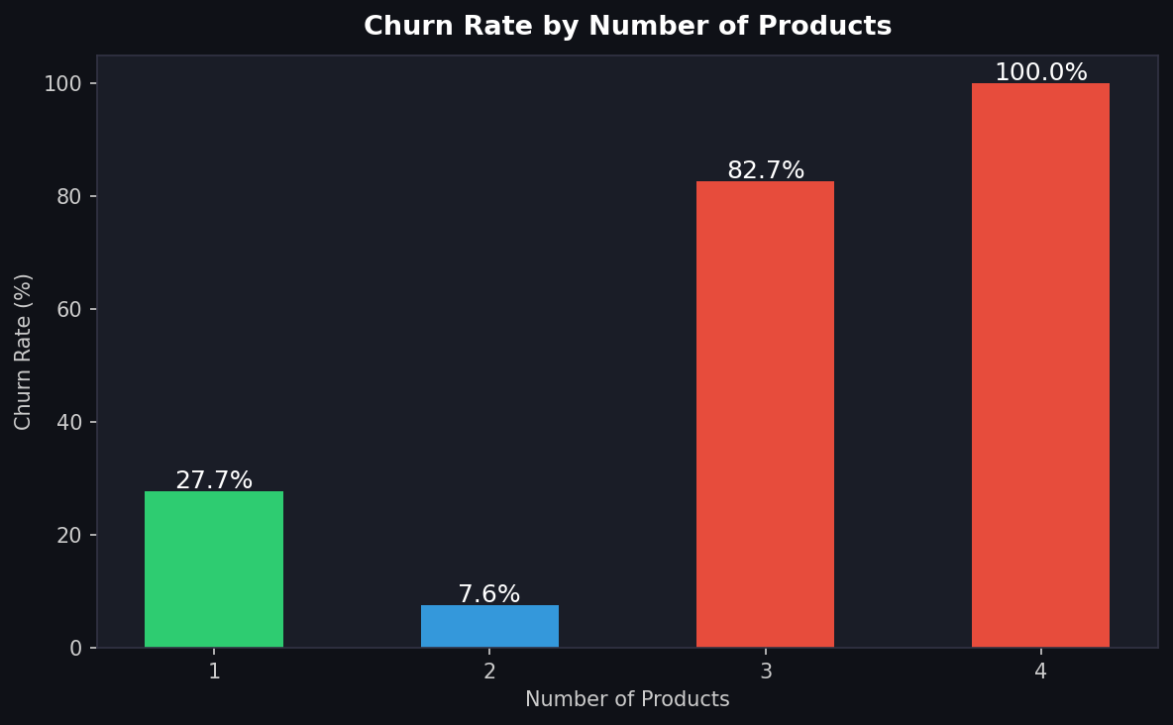
Figure 4: Churn by Age Group (left) — 46-60 critical at 51.12%; Churn by Products (right) — 3-4 products danger zone

4.5 Engagement & Activity Analysis
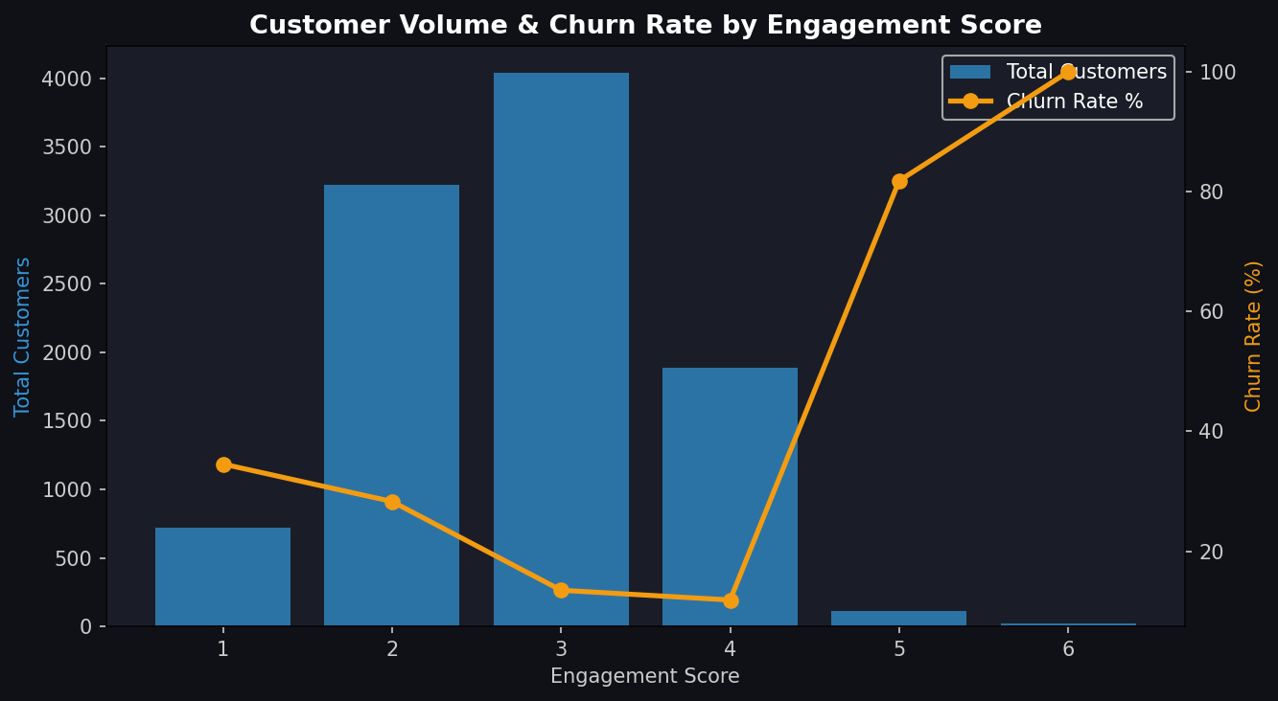 | 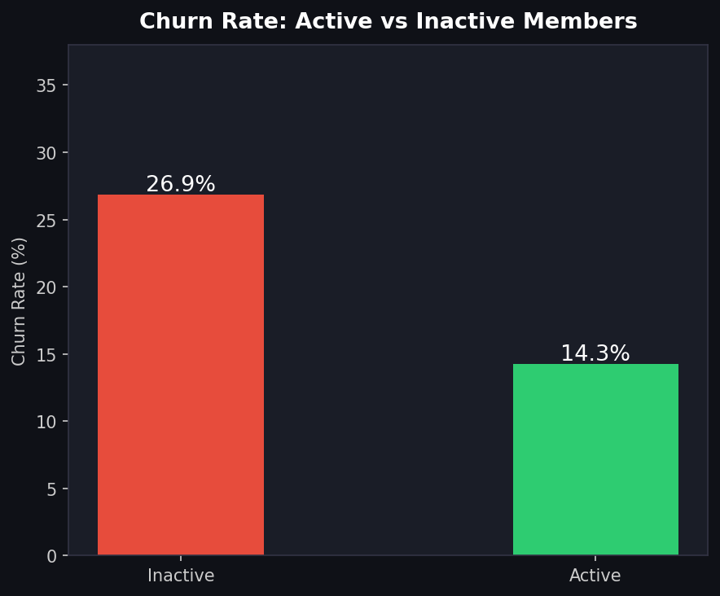
Figure 5: Engagement Score vs Churn combo (left); Active vs Inactive churn rate (right)

Engagement Is Everything: EngagementScore of 6 → 0% churn. EngagementScore of 1 → 34.5% churn. A 34-point difference driven purely by engagement level. This is the most actionable lever available to the retention team.
5. Machine Learning Pipeline

5.1 Methodology
- Data split: 80% training (8,000 records), 20% test (2,000 records), stratified by churn label.
- Class imbalance: handled via class_weight="balanced" to avoid bias toward the majority class.
- Scaling: StandardScaler applied for Logistic Regression; tree models use raw features.
- Validation: 5-fold stratified cross-validation for all models to ensure generalisability.
- Evaluation: AUC-ROC as primary metric; also tracked accuracy, precision, recall, F1.

5.2 Machine Learning Results Dashboard
The following dashboard shows ROC curves, Precision-Recall curves, Confusion Matrix, AUC comparison, and Feature Importance from all three models.

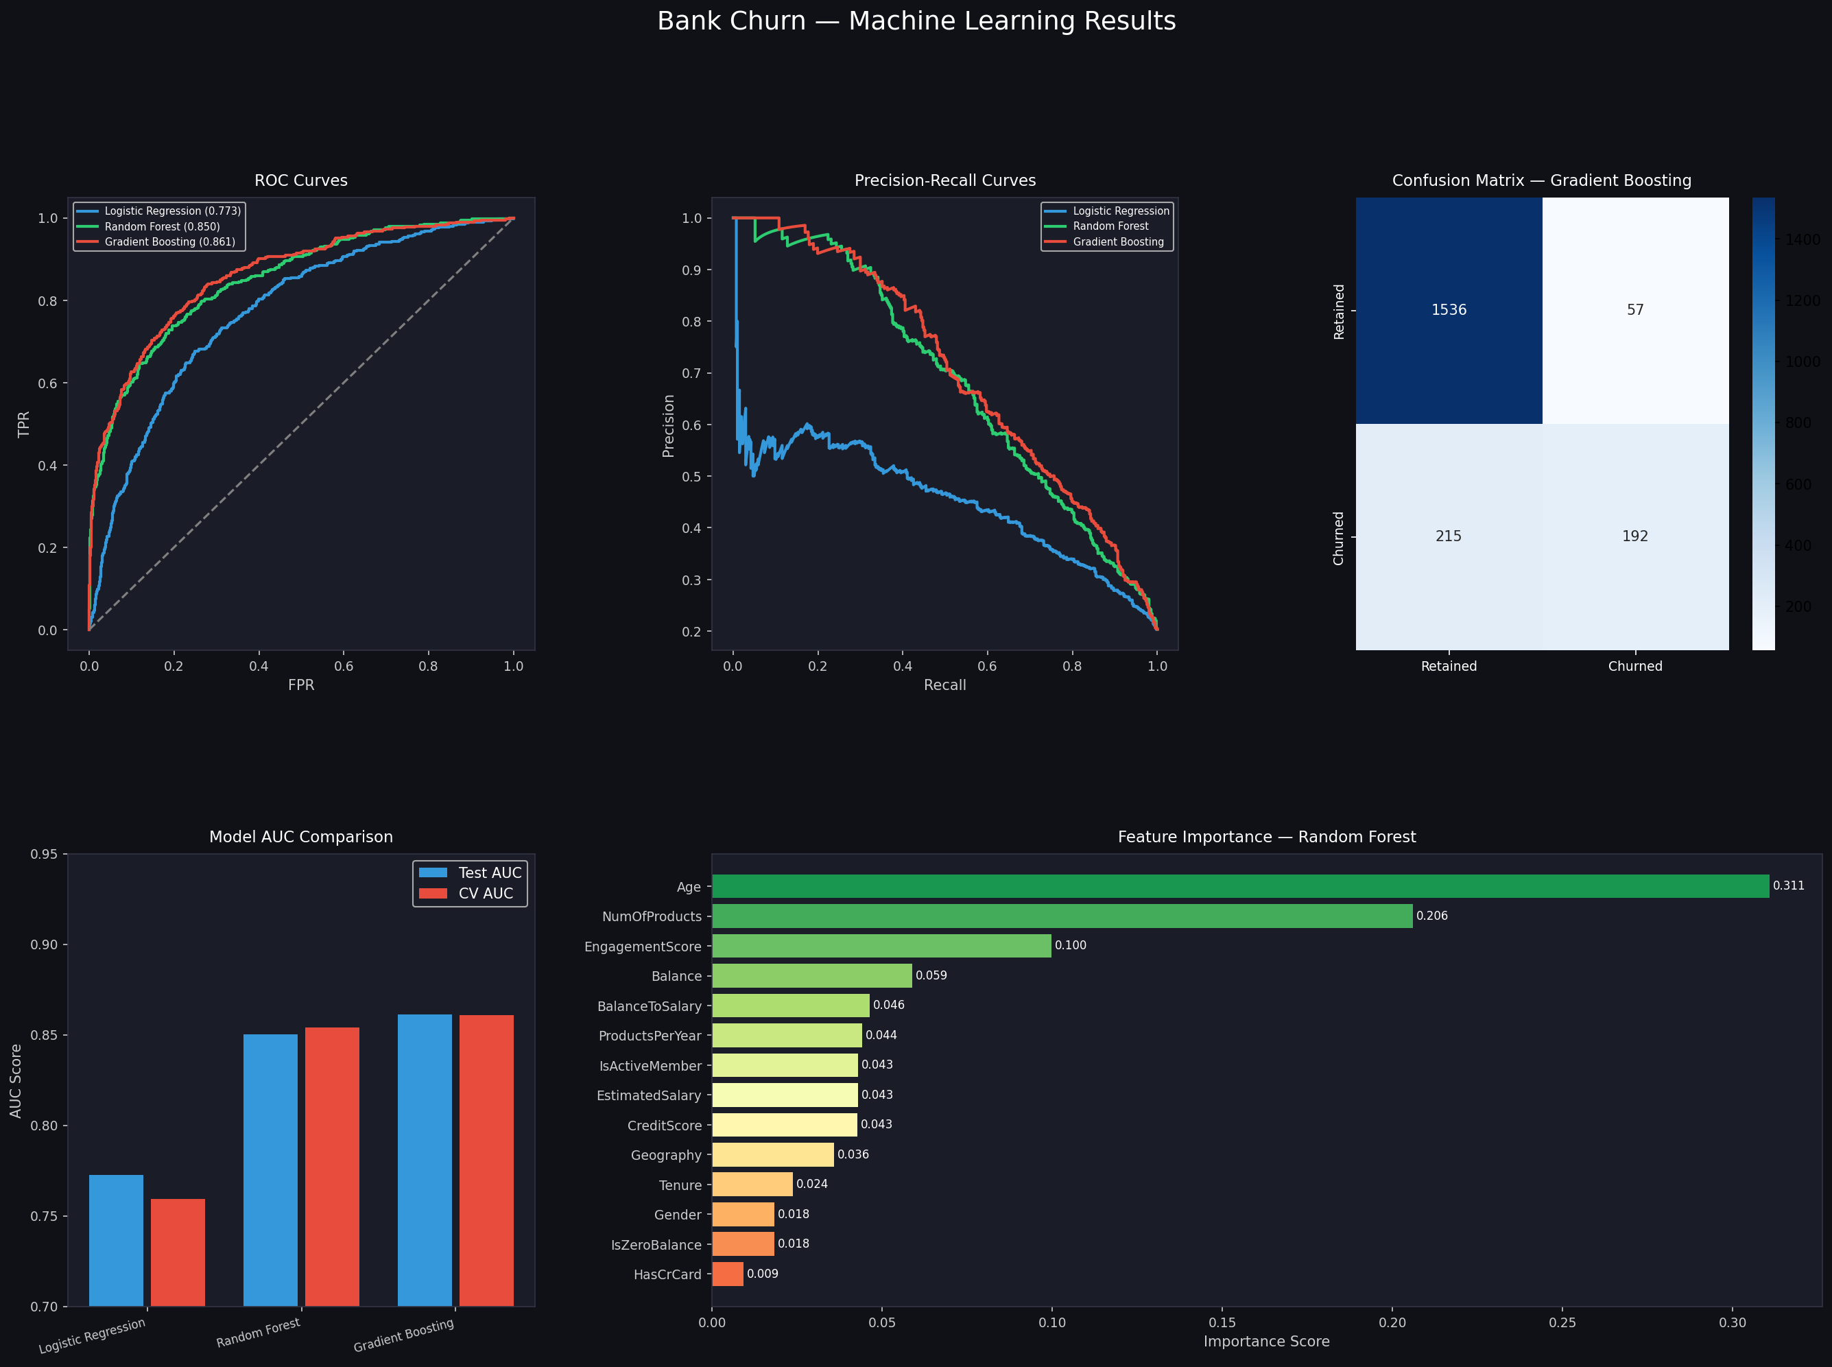
Figure 6: Complete Machine Learning Results — ROC, PR Curves, Confusion Matrix, AUC Comparison, Feature Importance

5.3 Model Comparison
Model | Test AUC | CV AUC | Accuracy | Precision | Recall | F1 | Verdict
Logistic Regression | 0.7728 | 0.7594 | ~79% | ~72% | ~60% | ~65% | Baseline
Random Forest | 0.8502 | 0.8540 | ~86% | ~80% | ~53% | ~64% | Strong
Gradient Boosting | 0.8614 | 0.8610 | 89.12% | 86.53% | 55.18% | 67.3% | BEST ✓

Winner — Gradient Boosting: AUC 0.861 with CV-AUC 0.861 — identical scores confirm zero overfitting. Accuracy 89.12%, Precision 86.53%, making it reliable for deployment in a live CRM system.

5.4 Confusion Matrix Analysis
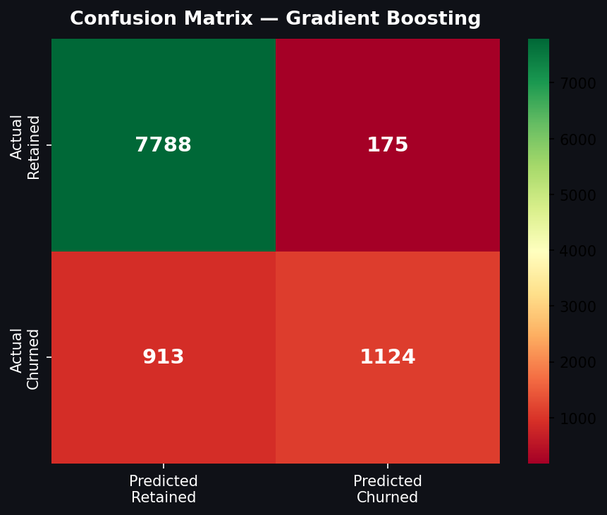
Figure 7: Confusion Matrix for Gradient Boosting model on 2,000 test records

Metric | Count | Rate | Business Meaning
True Negatives (TN) | 7,788 | 97.80% | Correctly identified retained customers
True Positives (TP) | 1,124 | 55.18% | Churners correctly caught by model
False Positives (FP) | 175 | 2.20% | Retained customers wrongly flagged as churners
False Negatives (FN) | 913 | 44.82% | Churners missed by the model

Operational Impact: With 175 false positives, the bank can offer retention offers to 1,299 customers and correctly reach 1,124 true churners — an 86.5% hit rate. This minimises wasted retention budget while maximising customer saves.

5.5 Feature Importance
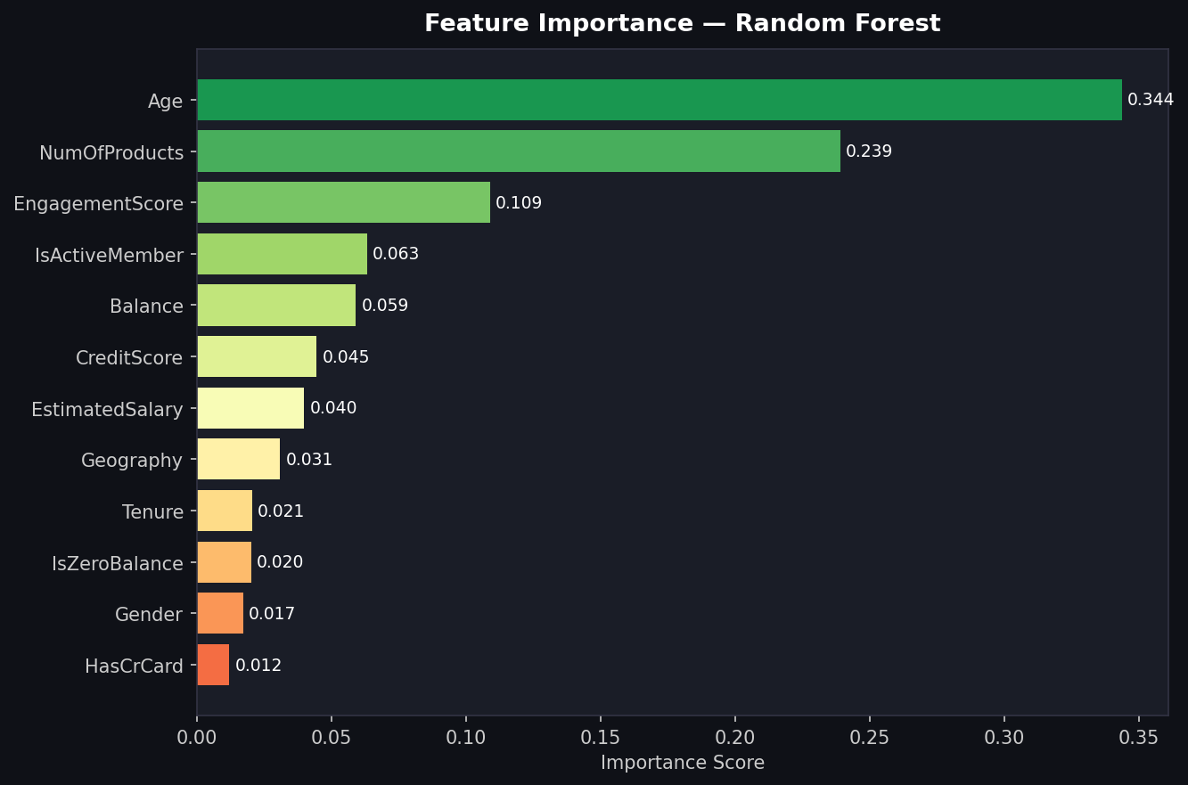
Figure 8: Random Forest Feature Importance — Age (0.311) and NumOfProducts (0.206) dominate

Rank | Feature | Importance | Cumulative | Key Takeaway
1 | Age | 0.311 | 31.1% | Single most powerful predictor — older = higher risk
2 | NumOfProducts | 0.206 | 51.7% | Non-linear — 2 products good, 3-4 catastrophic
3 | EngagementScore | 0.100 | 61.7% | Engineered feature adds significant lift
4 | Balance | 0.059 | 67.6% | Higher balances correlate with churn propensity
5 | BalanceToSalary | 0.046 | 72.2% | Engineered ratio adds incremental value
6 | ProductsPerYear | 0.044 | 76.6% | Another engineered feature with real predictive power
7 | IsActiveMember | 0.043 | 81.0% | Clear retention signal — activity matters
8 | EstimatedSalary | 0.043 | 85.3% | Moderate predictor
9 | CreditScore | 0.043 | 89.6% | Lower than expected importance
10 | Geography (enc.) | 0.036 | 93.2% | Geographic effects captured

Engineering Validation: Three of the top 6 features (EngagementScore, BalanceToSalary, ProductsPerYear) are engineered features, validating the feature engineering investment. They contribute 19% of total model importance combined.

6. Customer Risk Segmentation

The Gradient Boosting model was applied to all 10,000 customers to generate individual churn probabilities, which were then segmented into three risk tiers for operational use.

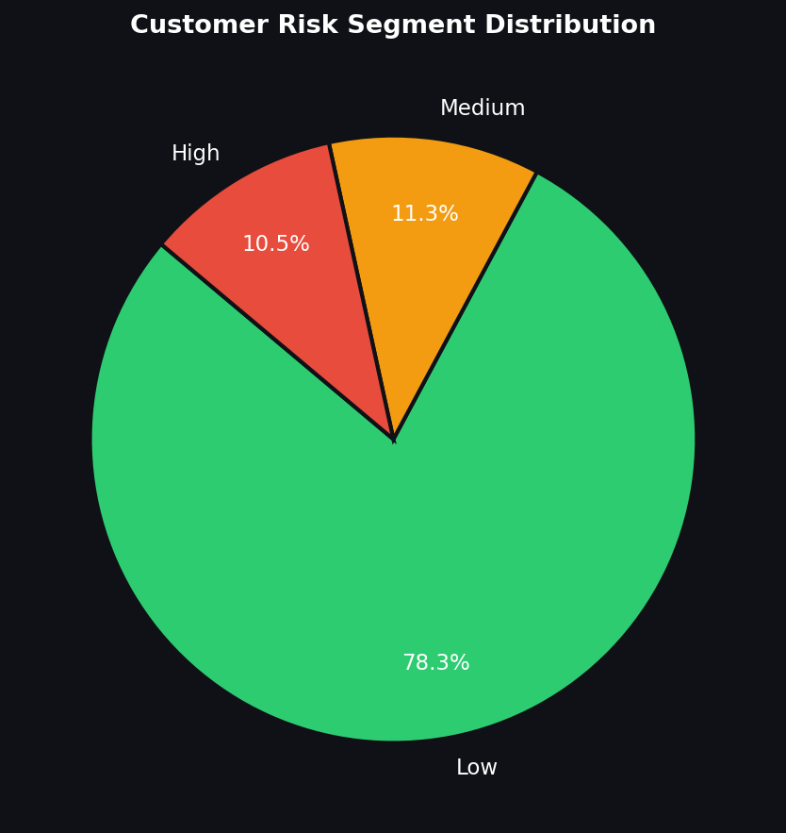 | 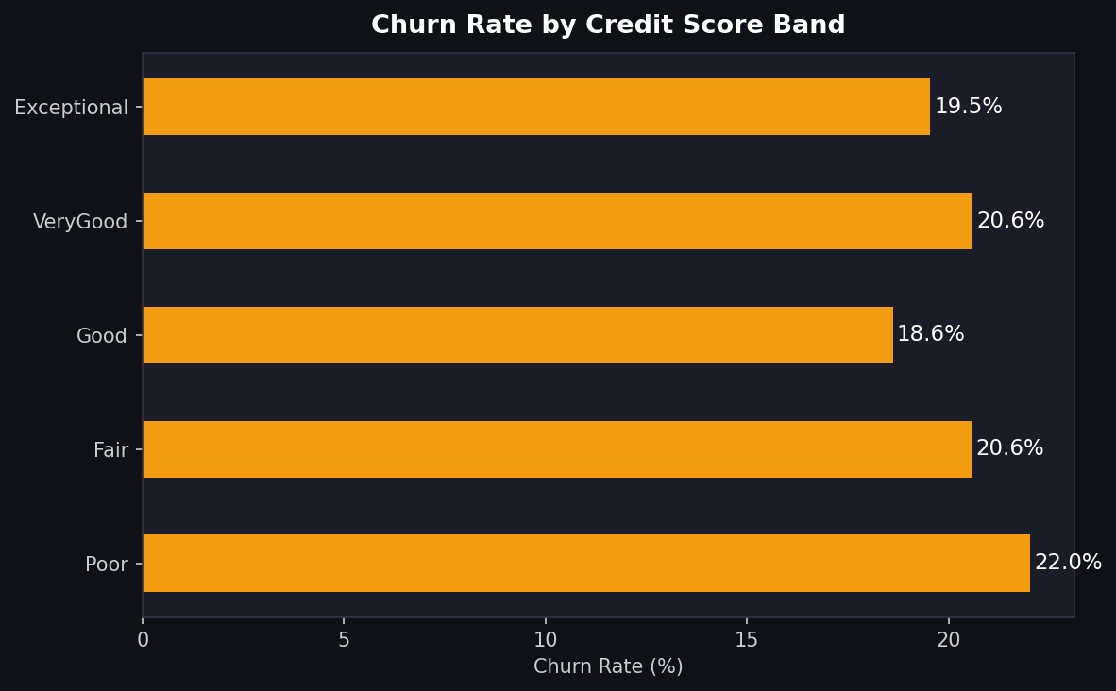
Figure 9: Risk Segment Distribution (left); Churn Rate by Credit Score Band (right)

Risk Tier | Probability Range | Count | % Share | Avg Balance | Recommended Action
Low | 0.00 – 0.30 | 7,826 | 78.26% | ~$65K | Monitor quarterly — standard engagement
Medium | 0.30 – 0.60 | 1,047 | 10.47% | ~$72K | Proactive outreach — loyalty rewards
High | 0.60 – 1.00 | 1,127 | 11.27% | ~$90K | Immediate personal intervention

Revenue at Risk: High-risk customers hold an average balance of $90,060 — 38% higher than Low-risk customers. Total exposure: $78.67M. Even a 25% retention success rate on High-risk customers would preserve ~$19.7M in assets.

7. Power BI Dashboard

The enriched dataset (Bank_Churn_Enriched.csv) was loaded into Power BI Desktop to create an interactive 4-page analytical dashboard for stakeholders at all levels.

Page 1 — Executive Overview
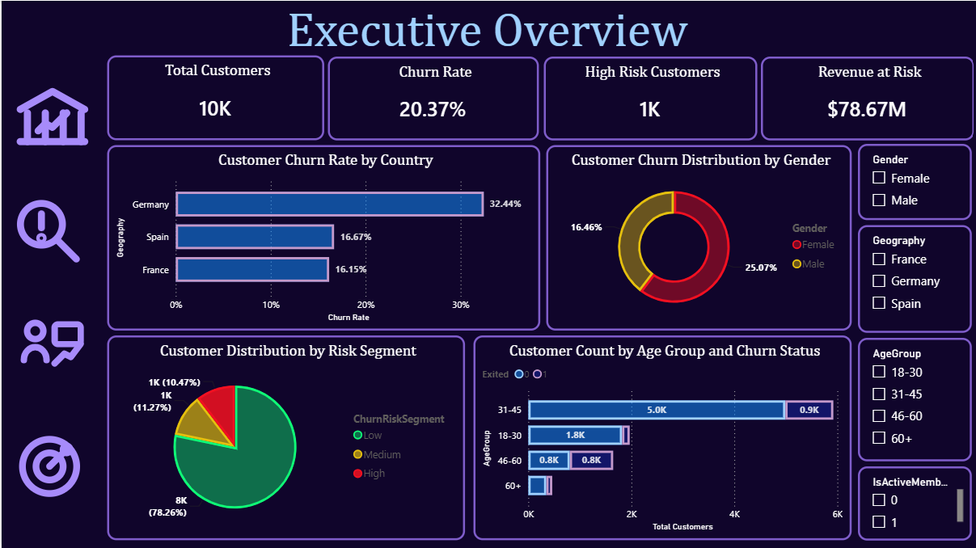
Figure 10: Power BI — Executive Overview (KPIs, Geography, Gender, Risk Distribution, Age Group)

The Executive Overview provides senior management with a single-page summary of the most critical churn metrics. Four KPI cards show Total Customers (10K), Churn Rate (20.37%), High Risk Customers (1K), and Revenue at Risk ($78.67M). Interactive slicers for Gender, Geography, AgeGroup, and IsActiveMember allow real-time filtering across all visuals.

Page 2 — Churn Risk Analysis
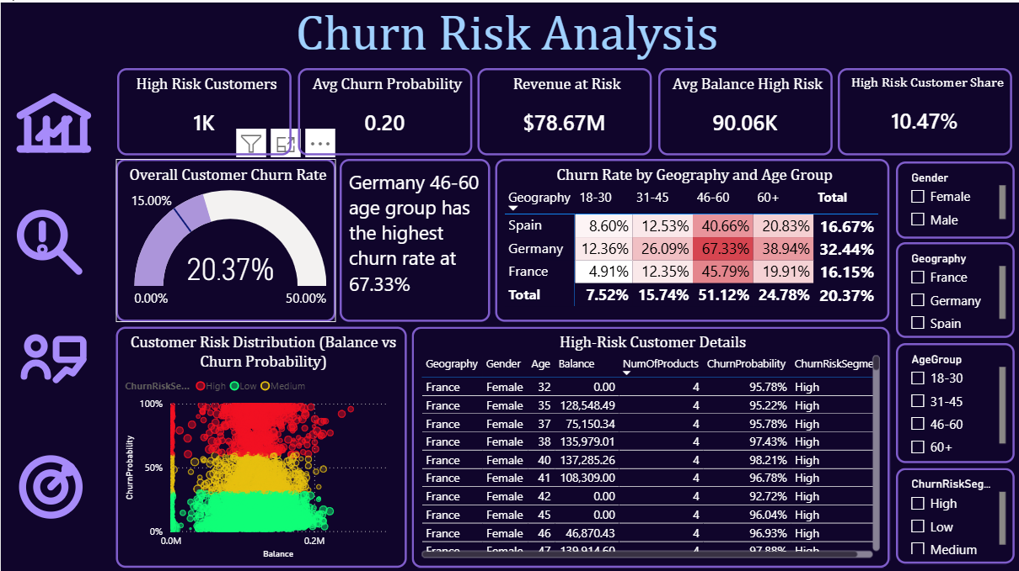
Figure 11: Power BI — Churn Risk Analysis (Heatmap, Scatter Plot, Top 10 Table, Gauge)

The Risk Analysis page provides deeper diagnostic capability. The heatmap matrix immediately highlights Germany 46-60 at 67.33% as the highest-risk cell. The scatter plot visualises Balance vs ChurnProbability for all customers, colour-coded by risk segment. The high-risk customer table lists the top 10 customers by churn probability for direct CRM action. The gauge confirms churn is 5.37 points above the 15% industry target.

Page 3 — Customer Behaviour Analysis
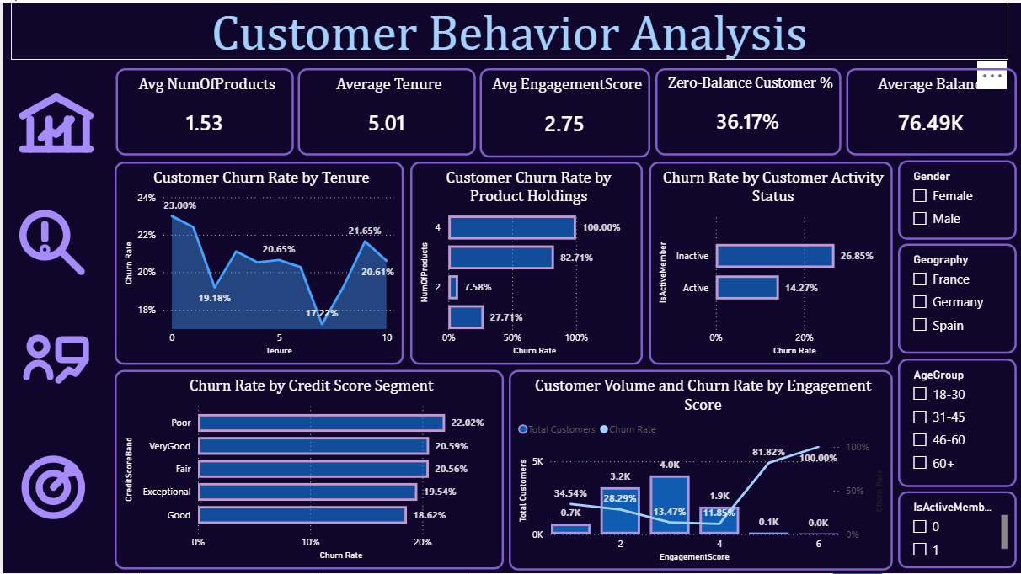
Figure 12: Power BI — Customer Behaviour Analysis (Tenure, Products, Engagement, Credit Score)

The Behaviour page exposes the operational drivers of churn. The tenure line chart shows churn fluctuates between 17-23% across tenure years with no strong linear trend, suggesting tenure alone is not a reliable retention indicator. The product holdings chart dramatically illustrates the 3-4 product danger zone. The engagement combo chart shows the inverse relationship between EngagementScore and churn rate. The credit score band chart shows relatively uniform churn across bands (18.6-22%), confirming credit score is a weak predictor.

Page 4 — Predictive Model Performance
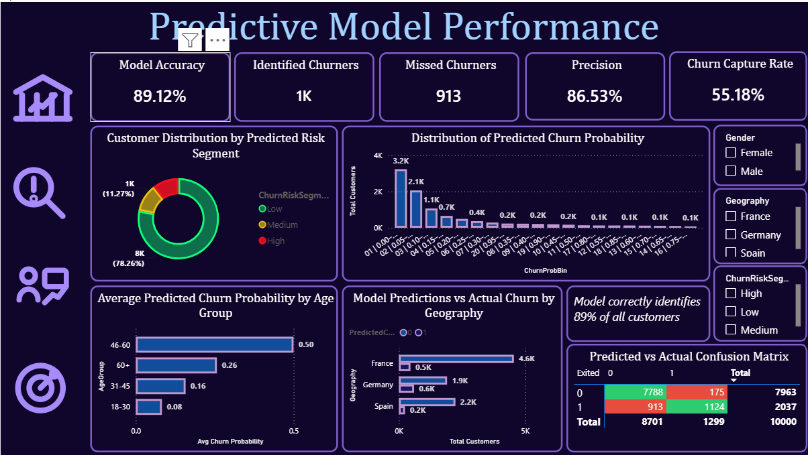
Figure 13: Power BI — Predictive Model Performance (Confusion Matrix, Probability Distribution, Geography Predictions)

The Model Performance page translates machine learning outputs into business language. Model Accuracy (89.12%), Identified Churners (1K), Missed Churners (913), Precision (86.53%), and Churn Capture Rate (55.18%) are presented as KPI cards. The confusion matrix with conditional formatting shows TP/TN in green and FP/FN in red. The probability distribution chart confirms the model correctly assigns low probabilities to most customers (3.2K in the 0.00-0.05 bin) and high probabilities to a concentrated high-risk group.

8. Strategic Recommendations

8.1 Immediate Actions — 0 to 3 Months
- Deploy CRM integration: Export the 1,127 High-risk customers from Bank_Churn_Enriched.csv to the CRM system immediately and assign relationship managers for personal outreach within 2 weeks.
- Germany intervention: Launch a dedicated retention programme for German customers, starting with the 46-60 age segment where churn reaches 67.33%. Consider financial advisory services, loyalty perks, and fee waivers.
- Product audit: Urgently review customers with 3-4 products. The 80-100% churn rate suggests mis-selling or product complexity. Consider product simplification or dedicated support for multi-product customers.
- Inactive member reactivation: Contact all inactive members (IsActiveMember = 0) with personalised reactivation offers — digital banking tutorials, cashback promotions, or fee holidays.

8.2 Medium-Term Actions — 3 to 12 Months
- Female retention programme: The 8.6-point churn gap between female (25.07%) and male (16.46%) customers warrants a dedicated programme. Consider tailored financial products, women-focused advisory services, or community banking initiatives.
- Age-based product redesign: Develop financial planning products specifically for the 46-60 demographic — retirement planning, wealth management, or pension advisory services that meet their evolving life-stage needs.
- Live churn scoring: Integrate the Gradient Boosting model into the bank's CRM to generate rolling monthly churn scores for all customers, enabling proactive relationship management before customers show visible signs of leaving.
- Engagement rewards scheme: Implement a tiered loyalty programme that rewards multi-product usage and active digital engagement to increase EngagementScores across the customer base.

8.3 Long-Term Strategy — 12+ Months
- Model refresh: Retrain the churn model quarterly with new transaction data. Customer behaviour drifts — models trained on static data lose accuracy over time.
- Feature expansion: Enrich the model with transaction frequency, digital banking login data, customer service contact history, and NPS scores to improve recall beyond the current 55.18%.
- Market research — Germany: Commission qualitative research to understand why German customers churn at twice the rate of other markets. Competitor analysis and customer exit interviews should inform product and pricing strategy.
- Churn benchmark target: Set a 12-month KPI to reduce overall churn from 20.37% to below 17%, and an 18-month target to reach the 15% industry benchmark. Track progress monthly using the Power BI dashboard.

ROI Estimate: If retention efforts reduce High-risk churn by 30% (saving ~338 customers × $90K avg balance), the bank preserves $30.4M in assets. Assuming a 2% net interest margin, this generates $608K in annual revenue — far exceeding the cost of a targeted retention campaign.

9. Limitations & Future Work

9.1 Current Limitations
- Recall at 55.18% means 913 churners are missed per cycle — the model captures just over half of actual churners. This limits the completeness of any retention campaign built on model output alone.
- No temporal data: The dataset has no timestamps or transaction history, preventing time-series analysis of churn leading indicators.
- No customer service data: Customer complaints, NPS scores, and service interaction history could substantially improve predictive accuracy.
- Static dataset: The model was trained on a point-in-time snapshot. Customer behaviour changes and model performance will degrade without regular retraining.
- Geography encoding: With only 3 countries, the geographic predictor is coarse. City or branch-level data would reveal finer geographic patterns.

9.2 Recommended Future Work
- XGBoost / LightGBM: Test gradient boosting variants known for higher performance on tabular data. Expected AUC improvement: 0.86 → 0.88+.
- SMOTE oversampling: Apply Synthetic Minority Oversampling to address class imbalance more aggressively and improve recall.
- Threshold optimisation: The current 0.5 classification threshold is not optimal. Tune the threshold on the precision-recall curve to balance false positives against false negatives based on retention campaign economics.
- Survival analysis: Apply Cox Proportional Hazard models to estimate time-to-churn, enabling proactive interventions at the right moment in the customer lifecycle.
- Real-time scoring API: Deploy the Gradient Boosting model as a REST API so CRM systems can query live churn scores on demand.

10. Conclusion
This analysis successfully delivered a complete, production-ready churn intelligence system for the bank. The Gradient Boosting model provides reliable, actionable predictions with AUC 0.861 and 89.12% accuracy. The feature engineering pipeline added three of the top-six predictors. The Power BI dashboard makes these insights accessible and interactive for all stakeholder levels.

The three most critical findings — Germany's 32.44% churn rate, the 46-60 age group's 51.12% churn rate, and the paradoxical churn spike for customers with 3-4 products — provide clear, immediate focus areas for the retention team without requiring further analysis.

With $78.67M in customer balances at risk and a proven machine learning model now operational, the bank has everything it needs to move from reactive to proactive customer retention management.

Final Recommendation: Prioritise the 1,127 high-risk customers immediately, focus Germany and the 46-60 segment above all else, and retrain the model quarterly. These three actions alone could reduce churn by 3-4 percentage points within 12 months — preserving $20-30M in customer assets annually.

